**Advanced SQL Exercises for Online Retail Store**

**Exercise 1: Ranking and Window Functions**

Goal: Use ROW_NUMBER(), RANK(), DENSE_RANK(), OVER(), and PARTITION BY.

Scenario:

Find the top 3 most expensive products in each category using different ranking functions.

Steps:

1. Use ROW_NUMBER() to assign a unique rank within each category.

2. Use RANK() and DENSE_RANK() to compare how ties are handled.

3. Use PARTITION BY Category and ORDER BY Price DESC.

1 :

SELECT *

FROM (

SELECT

ProductID,

ProductName,

Category,

Price,

ROW_NUMBER() OVER (PARTITION BY Category ORDER BY Price DESC) AS RowNum

FROM Products

AS RankedProducts

WHERE RowNum <= 3;

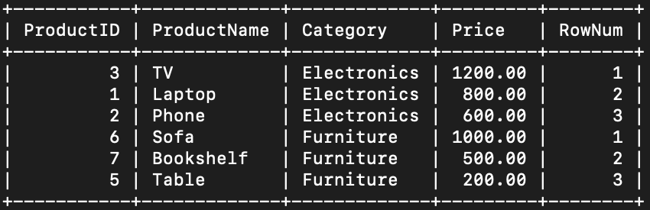

2 :

SELECT *

FROM (

SELECT

ProductID,

ProductName,

Category,

Price,

RANK() OVER (PARTITION BY Category ORDER BY Price DESC) AS PriceRank

FROM Products

) AS Ranked

WHERE PriceRank <= 3;

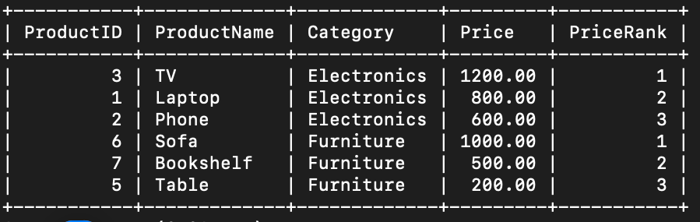

SELECT *

FROM (

SELECT

ProductID,

ProductName,

Category,

Price,

DENSE_RANK() OVER (PARTITION BY Category ORDER BY Price DESC) AS PriceDenseRank

FROM Products

) AS Ranked

WHERE PriceDenseRank <= 3;

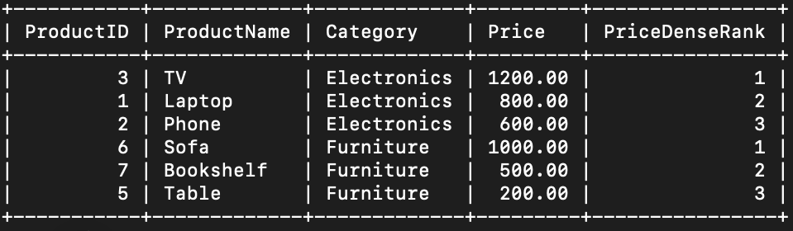

3 :

SELECT *

FROM (

SELECT

ProductID,

ProductName,

Category,

Price,

ROW_NUMBER() OVER (

PARTITION BY Category

ORDER BY Price DESC

) AS RowNum

FROM Products

) AS Ranked

WHERE RowNum <= 3;

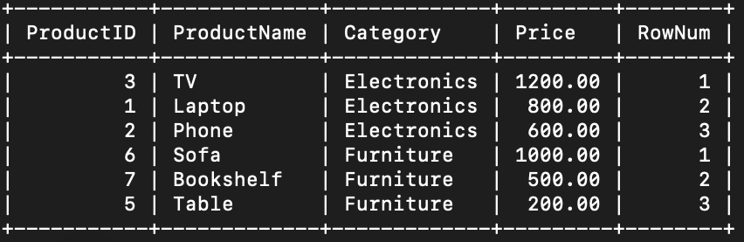

Exercise 1: Create a Stored Procedure

Goal: Create a stored procedure to retrieve employee details by department.

Steps:

1. Define the stored procedure with a parameter for DepartmentID.

2. Write the SQL query to select employee details based on the DepartmentID.

3. Create a stored procedure named `sp_InsertEmployee` with the following code:

CREATE PROCEDURE sp_InsertEmployee

@FirstName VARCHAR(50),

@LastName VARCHAR(50),

@DepartmentID INT,

@Salary DECIMAL(10,2),

@JoinDate DATE

AS

BEGIN

END;

INSERT INTO Employees (FirstName, LastName, DepartmentID, Salary, JoinDate)

VALUES (@FirstName, @LastName, @DepartmentID, @Salary, @JoinDate);

DELIMITER $$

CREATE PROCEDURE sp_InsertEmployee (

IN FirstName VARCHAR(50),

IN LastName VARCHAR(50),

IN DepartmentID INT,

IN Salary DECIMAL(10,2),

IN JoinDate DATE

)

BEGIN

INSERT INTO Employees (FirstName, LastName, DepartmentID, Salary, JoinDate)

VALUES (FirstName, LastName, DepartmentID, Salary, JoinDate);

END$$

DELIMITER ;



Exercise 5: Return Data from a Stored Procedure

Goal: Create a stored procedure that returns the total number of employees in a

department.

Steps:

1. Define the stored procedure with a parameter for DepartmentID.

2. Write the SQL query to count the number of employees in the specified department.

3. Save the stored procedure by executing the Stored procedure content.

